Date: October 30th, 2025

Via Certified Mail & Email
State farm
P.O. Box 106171,
Atlanta, Georgia 30348-6171

Attn: Kelly Kelly

Russell Rothbort, Esq
James Butler and Associates
300 Jericho Quadrangle Suite 260 Jericho, New York 11753
Phone: (785) 267-6444
Fax: (785) 267-7341

Re: Edward Burris v. Miguel batista colon
Claim No.: 3878L853X
Policy No.: 251833600132
Our File No.: [???]

DEMAND FOR ARBITRATION – UNDERINSURED MOTORIST CLAIM

Dear Ms. Kelly,

Please accept this correspondence as Plaintiff Edward Burris’s formal demand for arbitration pursuant to the Underinsured Motorist (“UIM”) provisions of the above-referenced policy issued by State Farm. As you are aware, this claim arises from the motor vehicle accident that occurred on December 23, 2024 in New York, wherein Mr. Burris, He was a Driver in a 2024 Nissan with Pennsylvania License Plate MMZ6881, was struck by another vehicle who left the scene. (See Attached Police Report). The vehicle left the scene, driven by [???] and owned by Miguel Batista Colon, denied coverage for our client’s loss.

As detailed in our prior demand dated May 7, 2025 (See Attached Demand Letter), Mr. Burris sustained significant injuries, including, cervical disc herniations, cervical radiculopathy, lumbar radiculopathy, right shoulder Partial supraspinatus tendon tear, Labrum tear and Bursitis, and associated neurological deficits, requiring extensive treatment, injections, and surgical interventions. Damages substantially exceed the liability coverage available from the at-fault driver.

Pursuant to the terms of the UIM endorsement in Mr. Burris’s policy, we hereby:

    - Formally demand arbitration of this Underinsured Motorist claim;
    - Appoint National Arbitration and Mediation (NAM) as our designated arbitrator;
    - Request that State Farm Company promptly designate its arbitrator in accordance with the policy;
    - Demand that State provide confirmation of its arbitrator within 30 days of this correspondence;
    - Enclosed please find the relevant policy declarations and prior demand letter for your reference.

We believe arbitration before NAM is appropriate, efficient, and consistent with the governing policy provisions and New Jersey practice. Should State fail to timely respond, we will proceed to enforce our client’s rights under the policy, including pursuing all available remedies.

Please contact the undersigned with your arbitrator designation or to discuss further.

Very truly yours,

COHAN LAW, PLLC

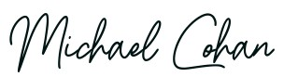

Michael Cohan, Esq.

EXHIBIT A

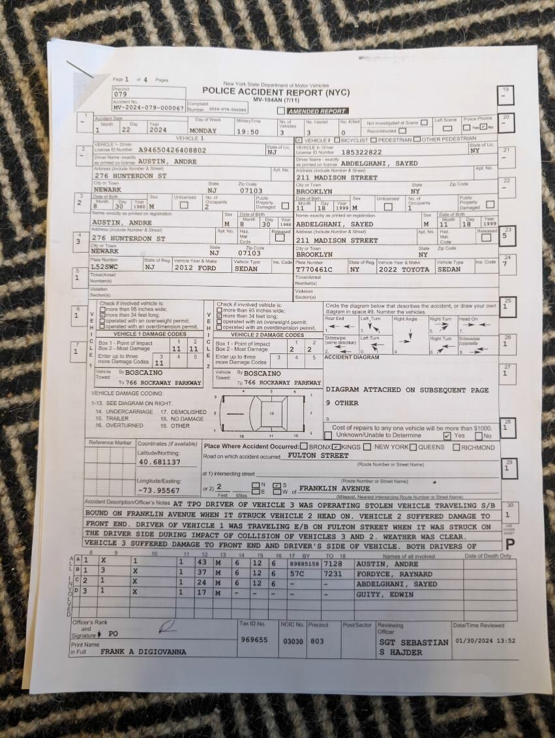

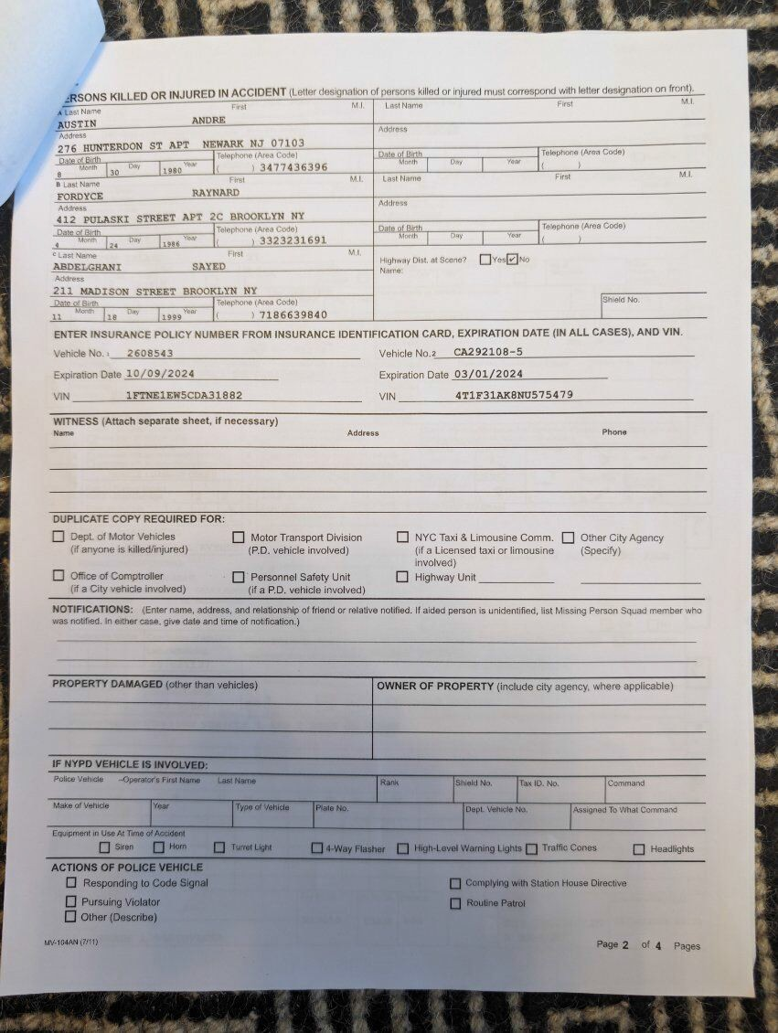

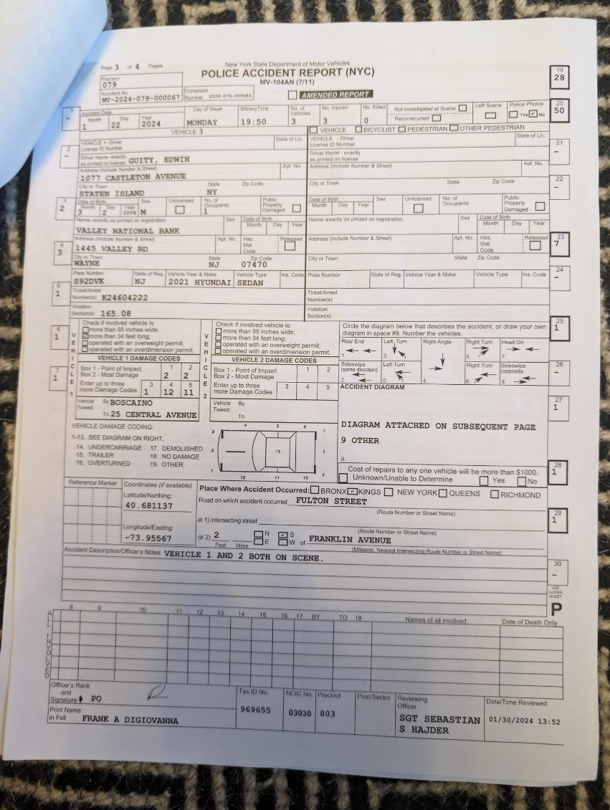

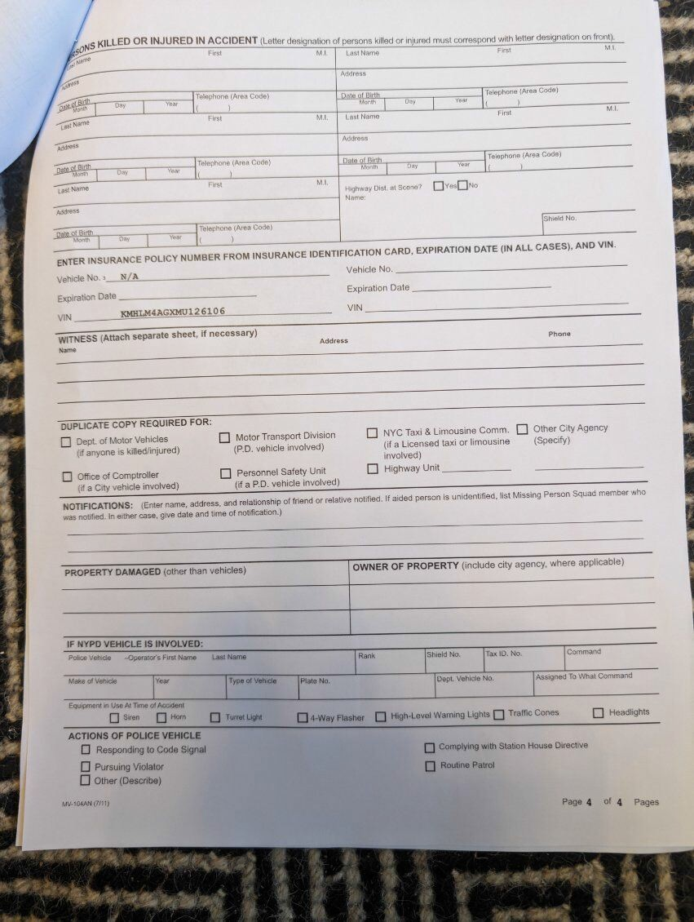

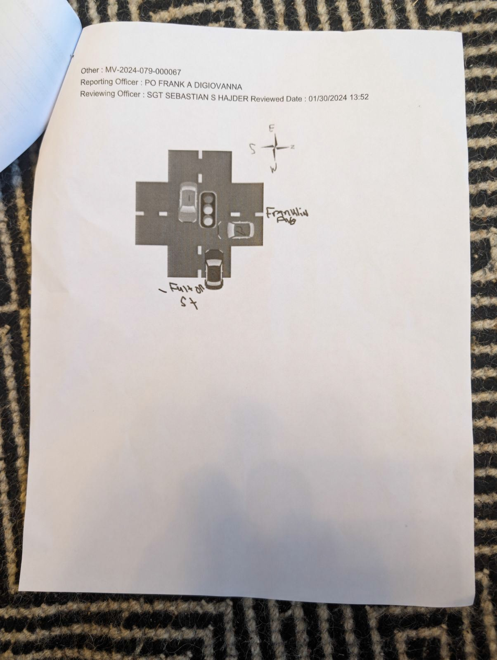

EXHIBIT B

DEMAND LETTER – REQUIRES RESPONSE
February 3, 2025

State farm
  - Box 8000
Ballston Spa, NY 12020

Attention: Kelly Kelly

Re: | Case: | Edward Burris v. Miguel batista colon et.al.
 | Claim #: | 3878L853X

To Whom It May Concern:

Plaintiff demands [???] to settle this matter. Please provide a full and final release of all claims in exchange for payment of your insured's policy limit. Plaintiff is responsible for repayment/reimbursement/satisfaction of all liens. Please respond to our
demand within seven (7) days. We believe a prompt settlement is prudent and reasonable.

You are obligated to notify your insured of this demand before rejecting it and communicate to you insured any settlement offer that could affect your insured's interests. Please contact us should you require additional time to evaluate this matter. State V.
County of Rensselaer, 26 N.Y. 3d 649, 657 (2016).

Liability: Our client was a passenger in your insured’s vehicle when a stolen vehicle struck your insured’s vehicle.

Damages: MRI Results
Cervical Spine MRI:

    - C3-4 and C4-5: Posterior disc osteophytes and uncovertebral spurring with mild right-sided foraminal narrowing at C3-4 and mild-to-moderate bilateral foraminal narrowing at C4-5.

- C5-6: Central osteophyte, right posterolateral disc herniation, and mild spinal cord deformity with right lateral recess narrowing and mild-to-moderate foraminal narrowing.
- C6-7: Disc bulge with mild thecal sac flattening but no significant stenosis or foraminal narrowing.

Lumbar Spine MRI:

- L5-S1: Disc bulge causing mild thecal sac flattening, mild lateral recess stenosis, and mild right- sided foraminal narrowing.
- L2-3 through L4-5: Mild disc bulges without significant stenosis.

Thoracic Spine MRI:

- Small distal thoracic and upper lumbar osteophytic spurs without evidence of destructive lesions.

Injections

  - Epidural Steroid Injections (ESI):
    - Locations: L4-L5 and L5-S1.

Facet Joint Injections:
    - Locations: Bilateral at L5-S1.
    - Purpose: Reduce pain and inflammation related to lumbar facet syndrome.

Trigger Point Injections:
    - Administered to relieve localized pain in the lumbar paraspinal muscles.

Procedures and Surgeries

  - Discectomy and Mechanical Decompression:
    - Level: L5-S1.

Nucleoplasty (Percutaneous Disc Decompression):
    - Levels: L4-L5 and L5-S1.

Annuloplasty:
    - Levels: L4-L5 and L5-S1.

Endoscopic Rhizotomy:
    - Performed bilaterally at L5-S1.

Facet Joint Fusion:
    - Location: Bilateral L5-S1.

Intraoperative Discogram:
    - Conducted during surgery to pinpoint pain-generating discs and confirm diagnoses.

Range of Motion (ROM) Test Results Cervical Spine:

- Flexion: 40° (normal: 60°).
- Extension: 40° (normal: 60°).
- Right Rotation: 50° (normal: 80°).
- Left Rotation: 45° (normal: 80°).
- Lateral Flexion: 30° bilaterally (normal: 50°).

Lumbar Spine:

- Flexion: 50° (normal: 90°).
- Extension: 10° (normal: 25°).
- Lateral Flexion: 5° bilaterally (normal: 25°).
- Rotation: 20° left, 10° right (normal: 30°).
- Pain and muscle stiffness were noted during all movements.

Thoracic Spine:

- Range of motion was functionally limited during extension and rotation due to stiffness and mild pain.

Thoracolumbar Spine Examination

  - Clinical Findings:
    - Paravertebral muscular spasms noted during palpation with tenderness at T12-L1 and lumbar regions.
    - Antalgic gait and difficulty with heel walking.

CT Scan Findings:
    - L5-S1: Disc bulging with mild thecal sac flattening, mild lateral recess spinal stenosis, and mild right-sided foraminal narrowing.
    - L2-L3 through L4-L5: Mild disc bulges without significant stenosis.

Straight Leg Raise Test:
    - Positive on the left side at 30°, indicating radiculopathy.

Neurological Findings

- Lower Extremity Sensory Deficits:
  - Impaired sensation in the left L5 and S1 dermatomes.
  - Reduced strength and reflexes in the left lower extremity.

Motor Strength Testing:
  - Weakness in left ankle dorsiflexion and plantar flexion, consistent with lumbar radiculopathy.
o

Notable Findings:

- The patient’s injuries include a lumbar herniation, meniscal tears, ACL damage, and soft tissue concerns such as subcoracoid bursitis. Procedures and treatments align with injuries resulting from an accident.

Should you fail to tender the policy limits in this matter, we recommend that your insured hire independent third party bad-faith counsel, as your interests conflict with your insured. Please contact our office to discuss settlement or request additional information.

Very truly yours,

Cohan Law, PLLC

Michael Cohan, Esq.

